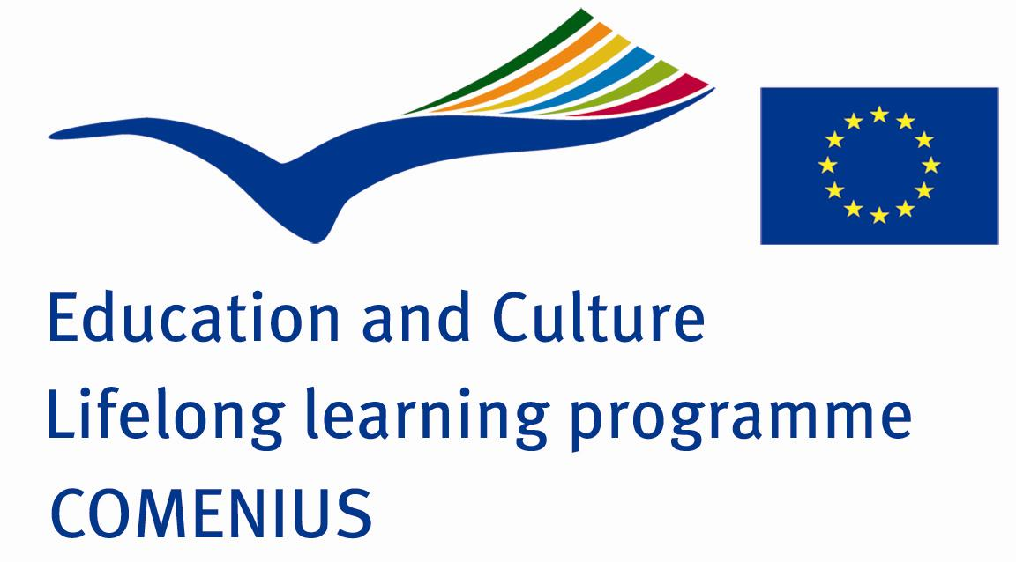

REPORT OF THE FIRST PROJECT MEETING

“STUDENTS RULE! - CITIZENSHIP AT SCHOOL – Promoting Linguistic Diversity through Digital Contents”

COMENIUS, LIFELONG LEARNING PROGRAMME

The first project meeting was held in Trzebinia (Poland) at Primary School No 6, from 2th November to 7th November.
School Partners:

Kasaba Sehit Yusuf Polat Yatili Ilkogretim Bolge Okulu /Turkey
Kildemarkskolen /Denmark
1st HIGH SCHOOL OF LEFKADA /Greece
IES BÁRBARA DE BRAGANZA /Spain
ISTITUTO COMPRENSIVO VIA GIOVANNI PALOMBINI/ Italy/Roma
I istituto Comprensivo Sacro Cuore / Italy/Sicily
Lycee Laperouse/France /New Caledonia
Lentiz Floracollege / The Netherlands
Melanchthon Kralingen / The Netherlands
Melanchthon de Blesewic / The Netherlands

Participating teachers:
1). Barbara Olearczyk-Marciniak ( English teacher and project coordinator), Poland
2). Agnieszka Łączka ( PE teacher), Poland
3). Stefania Głuch ( Vice head teacher, Nature teacher), Poland
4). Karolina Kowalczyk (English teacher), Poland
5). Magdalena Staroń (Math), Poland
6). Consuelo Carrero (English), Spain
7) . Remedios Tierno Galván (Head teacher), Spain
8). Maria Belluardo (English teacher), Italy/Sicily
9). Giovanni Di Mari (Head teacher), Italy/Sicily
10). Elvira Artale ( Italian, History and Geografy teacher), Italy/Sicily
11). Maria Antonietta Castiello (Maths and IT teacher), Italy/Roma
12). Alessia de Carolis (teacher), Italy/Roma
13). Angela Leone (suporting teacher), Italy/Roma
14). Anne Marie Veyret (Chemistry teacher), France
15). Françoise Rouam-Sim (History and geography teacher), France
16). Dimitris Rigas ( English and IT teacher), Greece
17). Nikolaos Konidaris( Head teacher),Greece
18). Anna Johansen ( Librarian and ICT-supervisor), Denmark
19). Inge Alfredsen (Danish,English), Denmark
20). Signe Schjelde ( Danish,English) , Denmark
21). Henk Meijer(International Project Coordinator, English teacher),The Netherlands
22). Sjors Beijer (JobTeacher),The Netherlands
23) Hatice Kaymaz ( English teacher),Turkey
24). Nurhan Agirman (XXX ), Turkey
25). Ad Kind (JobTeacher), The Netherlands
26). Simone Hartman(PE and religion teacher), The Netherlands
27). Gepke Römer ( JobTeacher) , The Netherlands
28). Miriam Rozendaal (PE), The Netherlands

Major Objectives:

- to use a variety of techniques to promote investigation of our differing cultures, systems of education
- to encourage transnational cooperation between schools
- to begin examining topics that promote living values
- to set up the roles of the partners
- to decide on

Completed Activities:

During the first project meeting the following activities have been completed:

- Welcoming at Primary School no 6 in Trzebinia /Poland.( 2nd Nov.2009 )

The Polish students were dressed in traditional folklore costumes and they welcomed the teachers and headmasters from the partner schools to their school. The students presented the most important places in Poland, the legends and most known Poles. The headmistress of the Polish school- Mrs. Małgorzata Stryjniak welcomed the guests as well.

- Project work ( 3rd- 6th Nov.2009 ) :
- Each partner school presented its country, region and town/ city, culture by using laptop, multimedia and Power Point Presentations;
- Discussion over the future project plans, deadlines and distribution of the project tasks. ;

they were decided as follows:

- E-twinning registration should be done by every of participants to make the communication be easier – November (Anna)
- Comenius corners/ the display area should be prepared in each partner school to let the students and local community know what is the project about, and who are the partner schools – as soon as possible
- Logos of the project should be designed by the students. The school competition should be organized in each country in order to chose the best one. One logo from each partner school should be sent to Dimitris /Greece - February, who is to organize the ‘Eurovision-like’ voting space for all the students participating in the project .Each school cannot vote for their own logo.
- Calendar photos should be taken and sent to Hatice/Turkey (1st December till 6th December).The form of the calendar is to be prepared by Miriam and Gepke before that deadline.
- School websites should be designed till next meeting (the end of March) and hyperlink it to the joint website of the project hosted in Denmark ( Anna )
- 1st questionnaires (50 students) will be designed and distributed via emails by Barbara / Poland - December/January
- Students’ portfolio – as soon as possible (at e-twinning portal)
- Lefkada meeting – 10th April
- New Caledonia meeting - August/September

- Project agreements concerning the activities, number of students participating in them

- Discussion over the living values, activities and mobilities

- Cultural and social activities:

Visit in the town of Trzebinia.; Visit in Wieliczka Salt Mine- the UNESCO World Heritage.; Sightseeing Cracow- the famous churches, museums, monuments. ; Visit in Auschwitz Museum, participation in the opening of new sports centre at Primary School no 6 in Trzebinia/Poland, meeting with the District and Town Authorities

